Proteins

**Proteins**

A protein is an organic compound made up of small molecules called amino acids, the monomers of proteins. There are 20 different amino acids commonly found in the proteins of living organisms. When amino acids bind together, they form a long chain called a polypeptide. A protein consists of one or more polypeptide chains. A polypetide chain generally looks like -NH-CH-CI. They all start with a -NH2 group and end with a -COOH group. In between the ends there are R-groups.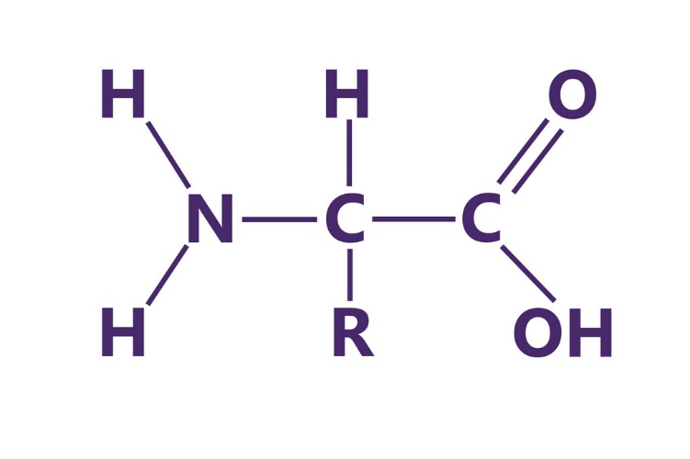

**Protein structure**

A protein may have up to four levels of structure. The lowest level, a protein’s primary structure, is its sequence of amino acids. The next level of protein structure, secondary structure, refers to local folded structures that form within a polypeptide due to interactions between atoms of the backbone. The most common types of secondary structures are the α helix and the β pleated sheet. The overall three-dimensional structure of a polypeptide is called its tertiary structure. The tertiary structure is primarily due to interactions between the R groups of the amino acids that make up the protein. Many proteins are made up of a single polypeptide chain and have only three levels of structure. However, some proteins are made up of multiple polypeptide chains, also known as subunits. When these subunits come together, they give the protein its quaternary structure.

